CSA1708-ARTIFICIAL INTELLIGENCE
LAB EXPERIMENTS

Program 1 : Python Program to Solve 8. Puzzle Problem
Aim
To develop a Python program that solves the 8-Puzzle
Problem using a search algorithm (such as Breadth-First Search - BFS) to find the shortest sequence of moves from the initial state to the goal state.
Algorithm
- Represent the puzzle as a 3×3 matrix.
- Define the goal state.
- Locate the empty tile (0).
- Generate all possible moves (up, down, left, right).
- Use Breadth-First Search (BFS) to explore possible states.
- Keep track of visited states to avoid repeated exploration.
- If the goal state is reached, display the solution path.
- If all possibilities are exhausted, report that no solution exists.

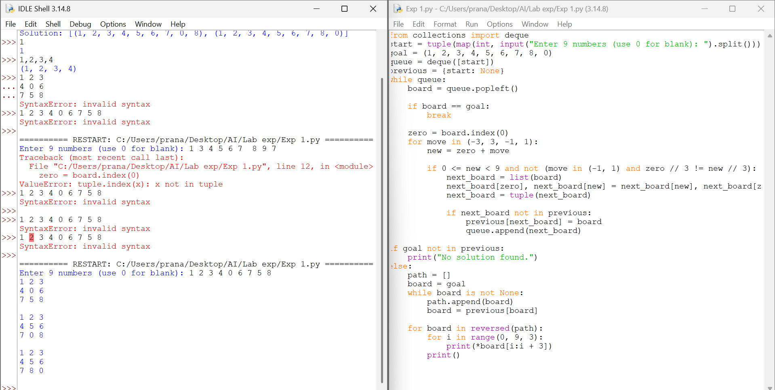

RESULT
Thus, the 8-Puzzle Problem solved successfully using Python.

